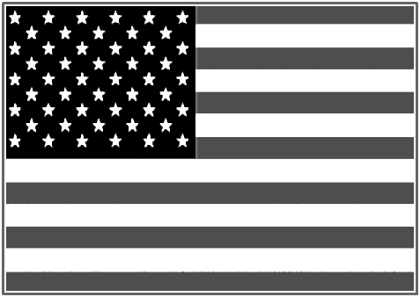

Michael Carney

February 10. 1932 ~ November 14. 2019

Rest In Peace

